# Week 14 Lab 1 Practical

# Duties of a DBA - Backup and Restore

**Completing this worksheet will help prepare you for the next mini assessment. This is a checkpoint, you may work in pairs.**

1. **What are some common tasks a DBA can be expected to complete? For each also list how often they should occur?**

**Auditing:**

An emerging task of the DBA is to identify which users are accessing, inserting, updating, or deleting data, and when. Auditing might only be necessary for limited time periods, for specific users, for very specific data, or it might be required 24/7 for all data.

**Backup and Recovery:**

One of the most fundamental aspects of the DBA’s job is to protect the organization’s data. This includes making periodic backups of data and keeping it safe from accidental or intentional destruction. In addition, a well-developed recovery plan needs to be implemented and tested so that when problems do arise, data can be restored quickly.

**Data Modelling and Database Design:**

The foundation of all efficient and scalable databases is good database design. DBAs often create database designs by performing needs / requirement analysis, creating a logical mode, and them implementing the physical model.

**Developing and Maintaining Best Practices:**

DBAs should be proactive in their work, and one of the best ways to be proactive is to develop sound database best practices and to implement them. The better organized and managed the database operations, the more efficient they will be. Ideally, an organization’s best practices will be documented for all to read and follow.

**High Availability:**

A DBA needs to ensure that their databases are available to users when they need access to data. There are many ways to help ensure high availability, including use of log shipping, clustering, database mirroring, and other technologies.

1. **How would you automate your production backups?**

* Expand SQL Server Agent -> Right click on Jobs -> Click New Job
* Enter Name, owner, description
* Click Steps -> Add New steps -> Add T-SQL command to take backup

**Ex:** BACKUP DATABASE students TO DISK = '/var/opt/mssql/backups/students.bak'

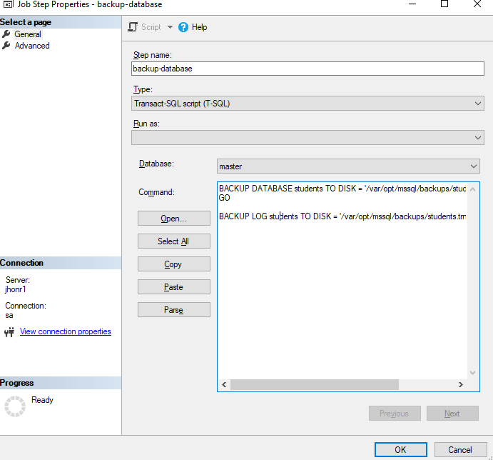

* Click Schedules -> Add New schedule -> Every week or hourly
* Enable the schedule type.
* Give OK.
* SQL Server Agent will perform the operation based on the schedule.

1. **How would you check your backups to validate that they were successfully created?**

* Go to docker container
* Run the command “docker exec -it jhonr1 ls -la /var/opt/mssql/backups”
* It will list the backups we mentioned in the Job.

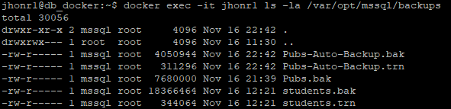

1. **List the three backup models in SQL Server and the associated pros and cons.**

**Full backup:**

The most common types of SQL Server backups are complete or full backups, also known as database backups.  These backups create a complete backup of your database as well as part of the transaction log, so the database can be recovered. This allows for the simplest form of database restoration since all the contents are contained in one backup.

**Pros:**

This backup provides the best protection for the data. No matter what happens to the hardware, we can restore the entire backup.

**Cons:**

Because these backups replicate so much information, they require a lot of storage space, time, and financial investment to complete.

**Differential backup:**

A "Differential" backup is a backup of any extent that has changed since the last "Full" backup was created.

**Pros:**

When compared to full backups, this form requires less time to restore and can offer different versions of the same files.

**Cons:**

Because we are backing up more data, these backups can consume far more storage space over time in comparison to other backups.

**Transaction Log backup:**

A transaction log backup allows us to backup the transaction log.  After the transaction log backup is issued, the space within the transaction log can be reused for other processes.  If a transaction log backup is not taken and the database is not using the Simple recovery model the transaction log will continue to grow.

**Pros:**

All the transaction details will be stored.

**Cons:**

As it needs a full backup before taking transaction log backup, it consumes more storage space over time.

1. **List the two ways these backup models can be set (include any syntax)**

BACKUP DATABASE Pubs TO DISK = '/var/opt/mssql/backups/pubs.bak'

BACKUP DATABASE Pubs TO DISK = '/var/opt/mssql/backups/pubs.bak' WITH DIFFERENTIAL

BACKUP LOG Pubs TO DISK = '/var/opt/mssql/backups/pubs.trn'

**Let have a quick run through. Files on the I: drive and in Gitlab.**

**Install the Pubs database on your containerised MSSQL Server (installpubs.sql).**

**Take a full backup of your Pubs database (make sure you have closed any query windows).**

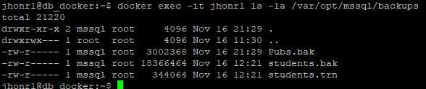

**Insert the Pubs data.**

**Take a differential backup.**

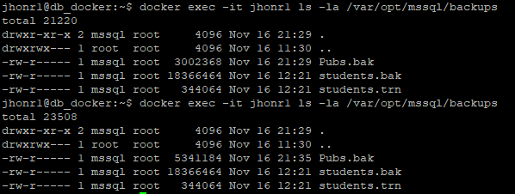

**Insert a new author <YourName> (or update an existing author).**

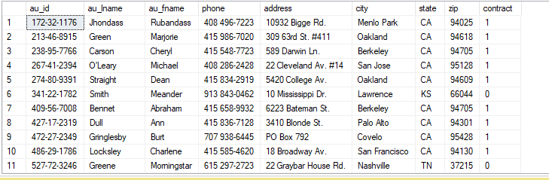

**Take a differential backup.**

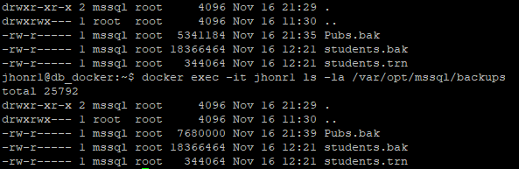

**Restore the full backup only (explore the Options and the Timeline)**

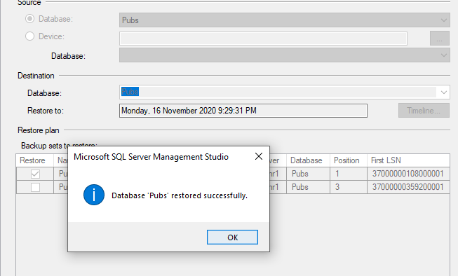

**Verify there is no data.**





**Restore the full backup + differential + transactions logs.**

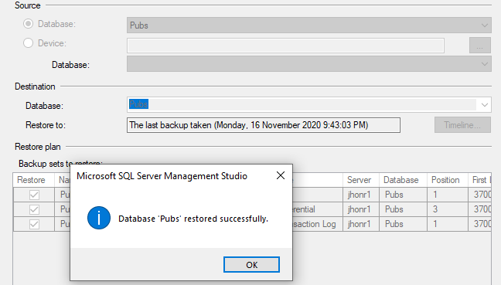

**Confirm your data is in its most recent state.**

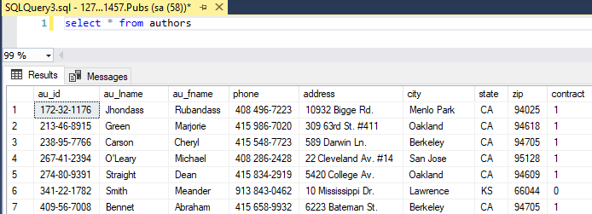

**DBCC CHECKDB for allocation or consistency errors.**

